Reminder to disable ASLR before continuing
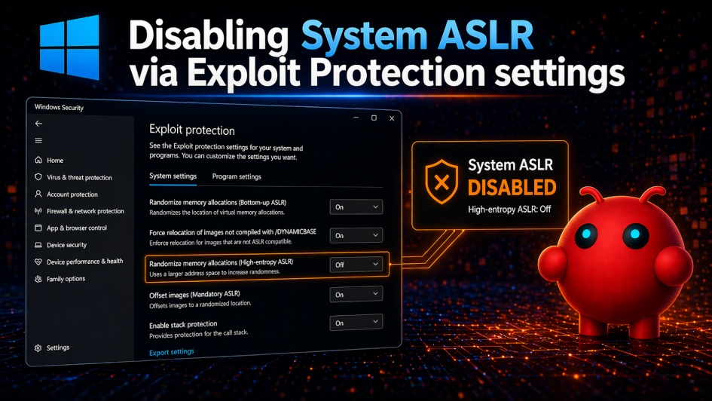
In the next lesson, we will combine both x64dbg and Ghidra to solve a crackme. Before you proceed, please remember to disable ASLR at both the system level and for the crackme you are going to analyze.
As explained in the previous lesson, system-level ASLR only needs to be disabled once. However, for target programs, you must disable ASLR individually for each binary (whether it’s a crackme or any other software) that you want to analyze.
This step is important because Ghidra and x64dbg handle addresses differently. In Ghidra, the target binary is loaded at its preferred (default) base address. In contrast, x64dbg is a runtime debugger, so when the operating system loads the binary, it may assign a different base address if ASLR is enabled.
We need both x64dbg and Ghidra to load the target binary at the same base address so that OpenClaw can use insights from one tool to effectively assist the other.
As a result, the addresses you see in Ghidra may not match those in x64dbg unless ASLR is disabled. To verify the default base address, you can use Detect It Easy (DiE), as demonstrated in the previous section.

